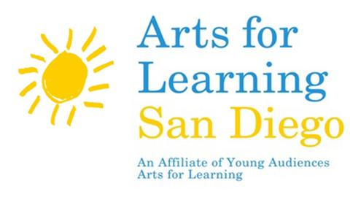
A4LSD Partners with Coronado Unified School District

Providing the Entire District with Arts Integration Services from 2017-2021.

Arts for Learning is partnering with Coronado Unified School District for the next 4 years through a DoDEA grant. DoDEA stands for Department of Defense Educational Activity. The focus of this grant is to serve schools that have high populates of military connected students. Our partnership with CUSD will allow us to provide arts integration to all students in the district, enabling us to partner with classroom teachers, combining arts curriculum with English Language Arts. A4LSD teaching artists and CUSD classroom teachers will work together to develop literacy and arts curriculum, increase student engagement in English Language Arts, support military-connected students and empower classroom teachers to use arts in the classroom.

What does this look like? Each classroom will get to work with a teaching artist for up to 20 hours in a single art form (e.g. Kindergarten dance with a focus on storytelling and character development). Each classroom will work in a different art form in successive years, ensuring that students and classroom teachers get exposed to dance, theatre, music, and visual art throughout the partnership. As part of this initiative, Arts for Learning will be providing professional development to Coronado classroom teachers on the topic of arts integration, increasing their capacity to utilize the arts as a way to enhance academic curriculum of all kinds.

In addition, Arts for Learning will be providing Performance Assembly Programs and Family Arts Nights across the district due to a generous grant we received from the California Arts Council Veterans Initiative in the Arts during the 2017-2018 school year.

A4LSD is excited to be entering into a multi-year partnership with another school district in the realm of arts integration. What a powerful way to deepen education and collaboration in service of our students and their knowledge and engagement!

